Membership Application Form
Individual:
☐ Annual: £25 ☐ Life: £200
Joint (two individuals):
☐ Annual: £35 ☐ Life: £275
Name(s):

Address:

Post Code:
Telephone:
Email:
I enclose remittance /Banker’s Order for:
£ ……………..
Gift Aid
You can Gift Aid your donation provided you pay an amount of income and/or capital gains tax at least equal to the amount we will claim (25p per £1).
Please tick the box if you wish to do so: ☐
Signature:
Date: ….…/….…/….…
Banker’s Order
To the Manager
Bank plc.
Address:

Please pay to:
Barclays Bank plc.
Market Square
Penrith. CA11 7YB
Sort Code: 20-66-97
For the account of Thornthwaite cum Braithwaite
Parochial Church Council. A/C No: 10874965

The sum of £ ……………..
Monthly / Quarterly/ Annually (delete as appropriate)
Commencing on ….…/….…/….… and until further notice by me.
To the debit of account:
Name:
Account Number:
Signed:
Date: ….…/….…/….…

Please send the completed form to:
Administrator (Friends of Newlands Church)
Greystones
Braithwaite, Keswick, Cumbria
CA12 5SZ
Friends of
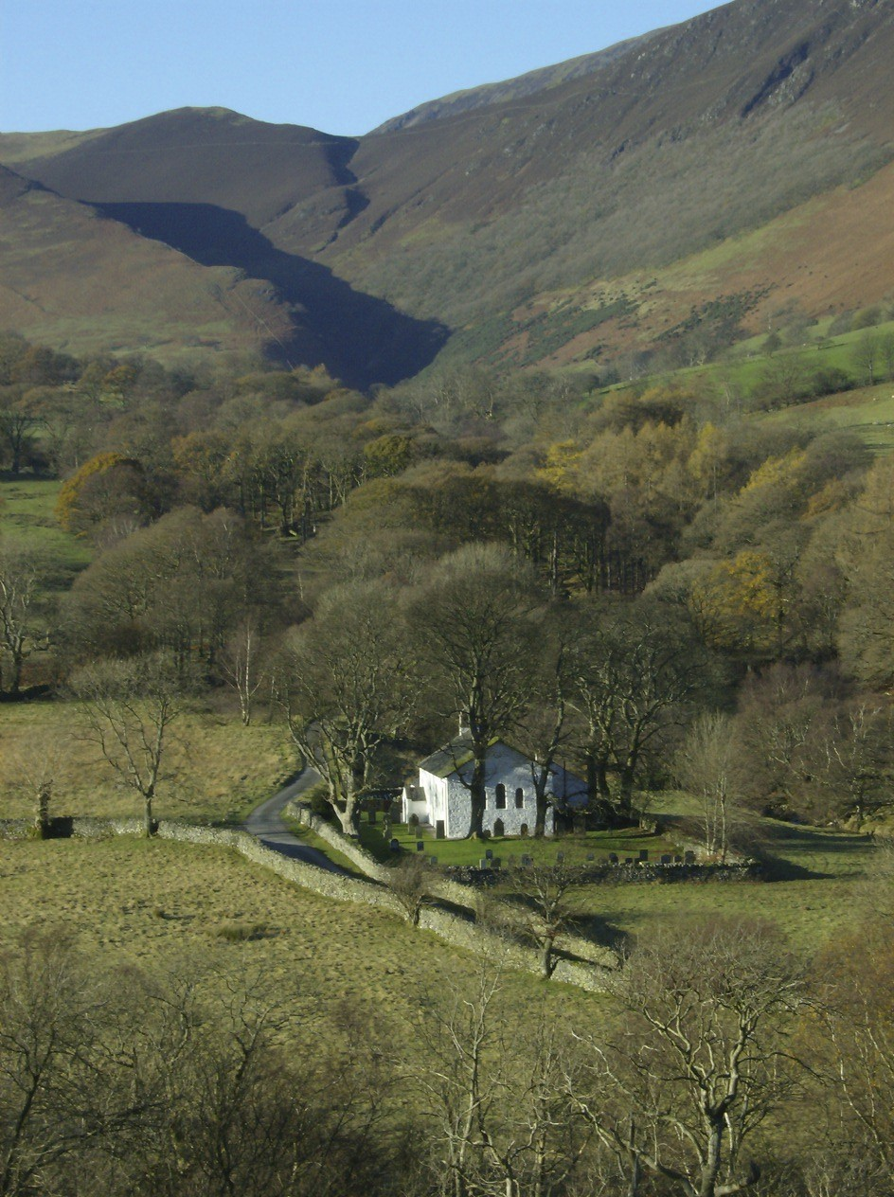
Newlands Church

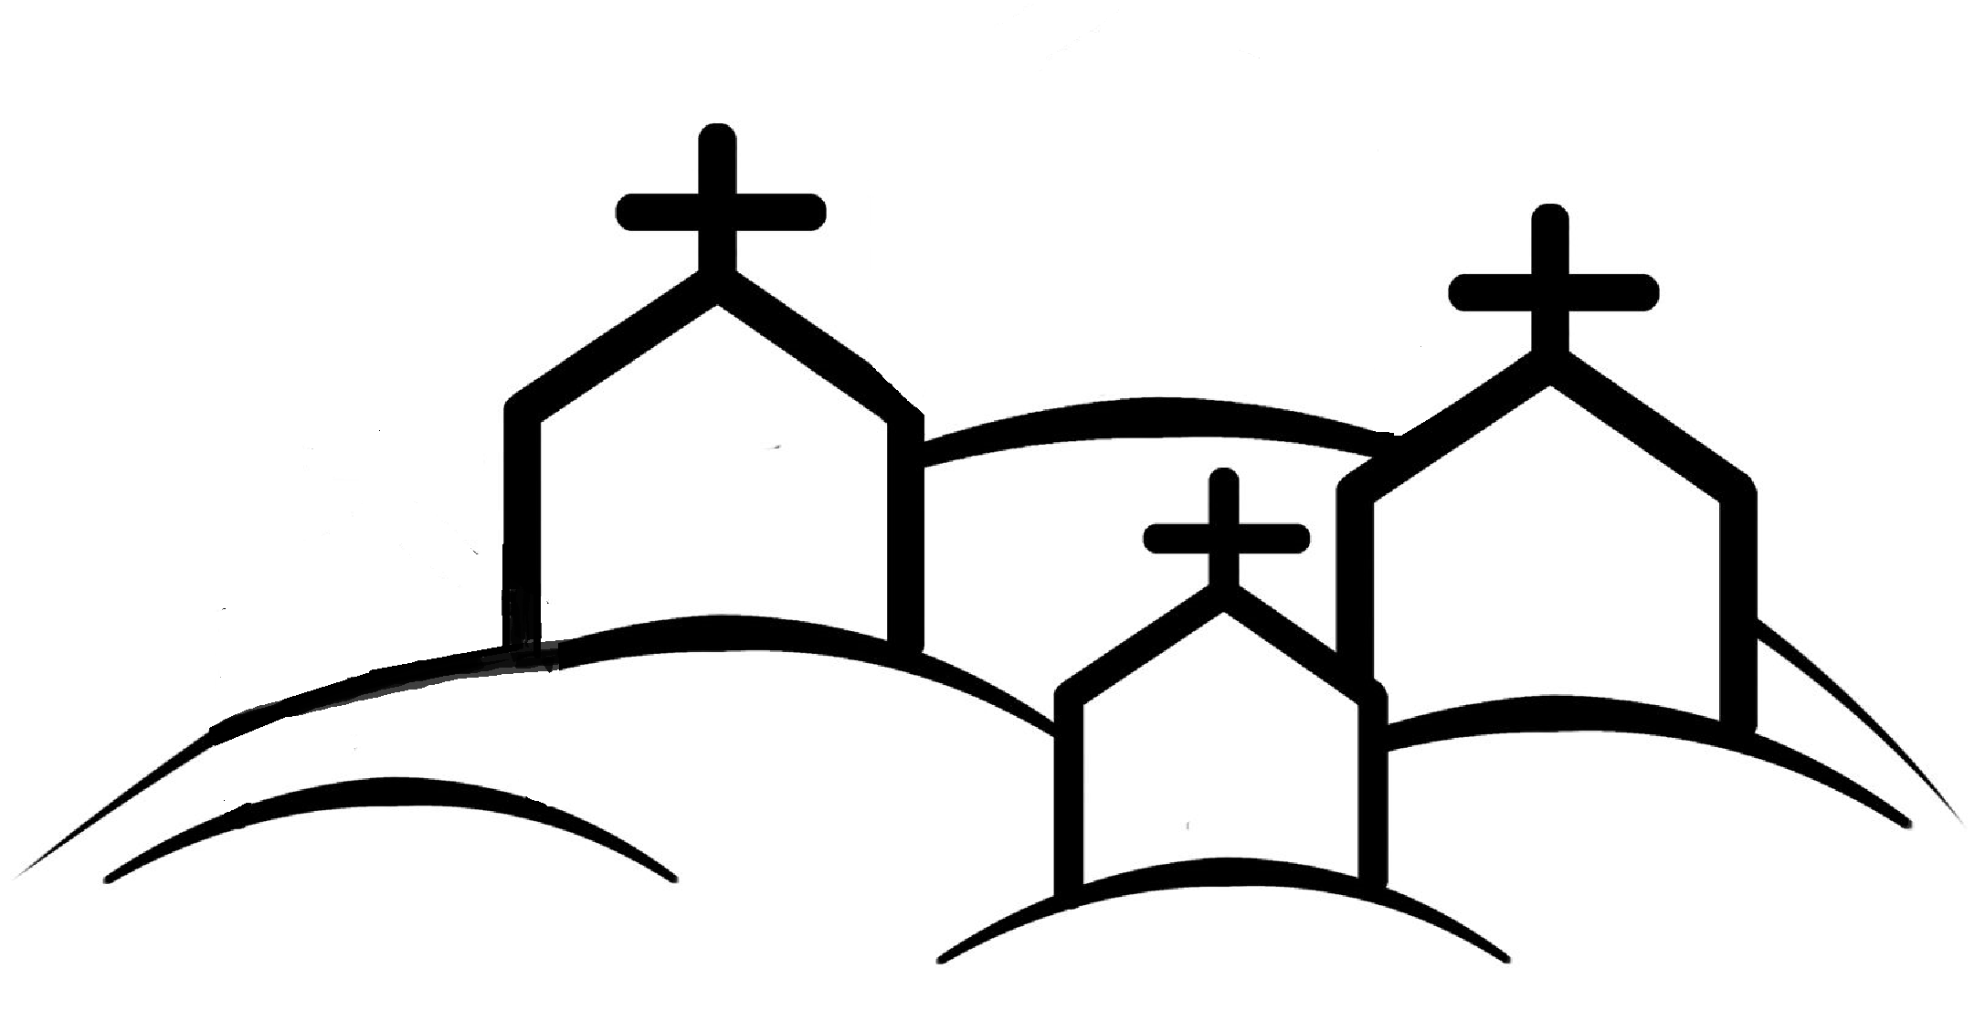
Join today and help us preserve this unique church

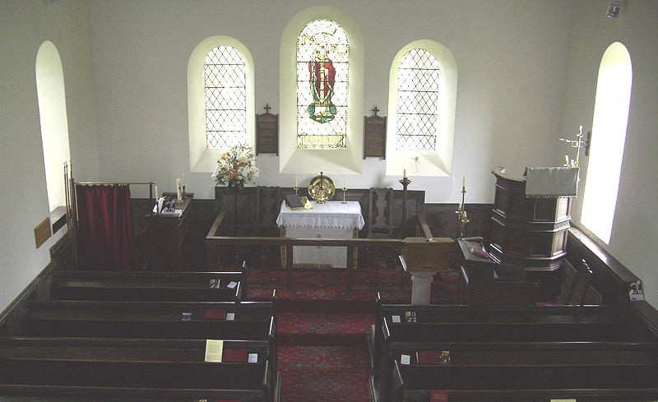
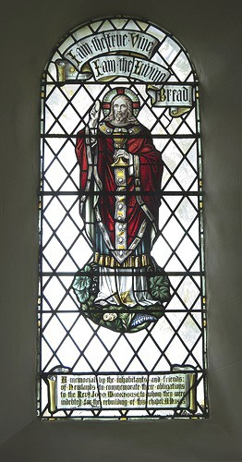
We believe Newlands Valley wouldn’t be the same without the Church and feel sure visitors would agree and would want to help ensure its continuing presence for future generations.

Why do we need your help?

We endeavour to meet our day to day costs from within the local worshipping and wider community, but we also need to be able to meet the larger non-regular maintenance costs as and when they arise. Our latest architectural inspection estimated that some £30,000 would be required over a five year period to keep the church in a satisfactory condition.

Donations from Friends have already helped with funding for works to the roof and school room windows. The next project involves repairs to the stained glass windows, including bringing protection up to present day standards.

What can you do to help?

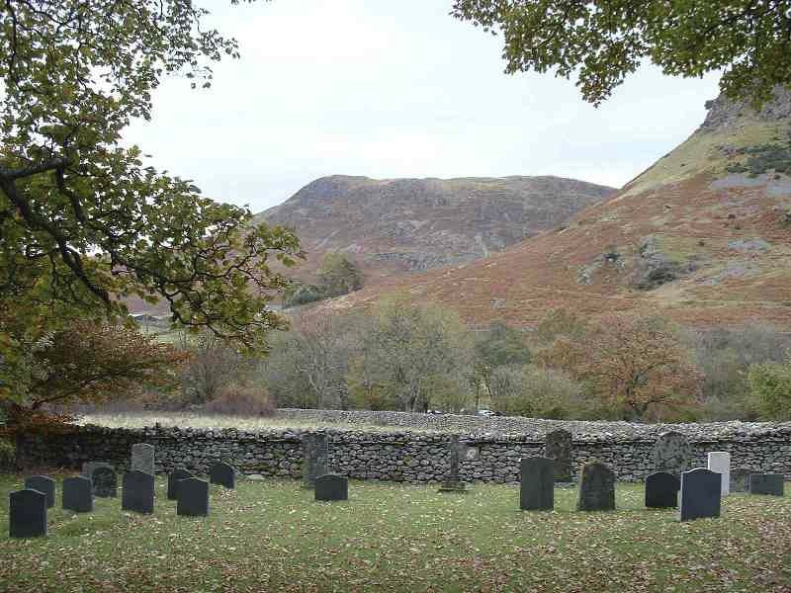
By joining the ‘Friends of Newlands Church’ you’ll be contributing to meeting these costs and helping secure its future by keeping the fabric of the building in good condition.

We will keep you up to date by sending an annual Newsletter.

History

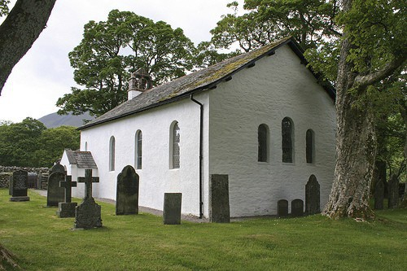
The exact date of the origin of Newlands Church is not known but there is reference to a chapel on this site in the mid 16th Century.

By the early 1840s the church was in a rundown state and John Monkhouse the then Curate took up the task of raising funds for rebuilding.

Around the same time the adjoining school was added, remaining open until 1967.

In 1885 further major internal refurbishment took place, and this is substantially the building as it remains today.

Today

The church is open during the day, and all are welcome to visit, to spend some time here and take in the unique atmosphere.

The church is available for weddings and other special services, such as the renewal of marriage vows, and the schoolroom can be hired for small group meetings.

